Russia election: Vladimir Putin wins by big margin
12 minutes ago
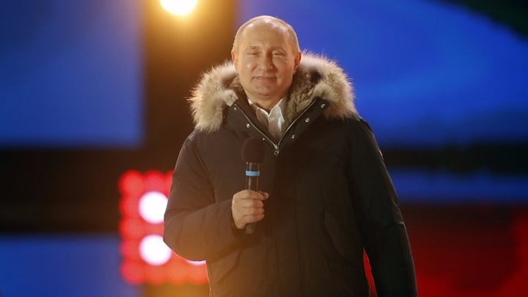

Vladimir Putin: "I can see the recognition of what has been done over the last few years"
Exit player
Media captionVladimir Putin thanked the crowd in a victory speech in Moscow Vladimir Putin will lead Russia for another six years, after securing an expected victory in Sunday's presidential election.
Mr. Putin, who has ruled the country as either president or prime minister since 1999, got more than 76% of the vote, official results show.
The main opposition leader, Alexei Navalny, was barred from the race.
Addressing a rally in Moscow, Mr. Putin said voters had "recognized the achievements of the last few years". Speaking to reporters after the results were announced, he laughed off a question about running again in another six years.
"What you are saying is a bit funny. Do you think that I will stay here until I'm 100 years old? No!" he said.
The scale of victory - which had been widely predicted - appears to be a marked increase in his share of the vote from 2012, when he won 64%.
Mr. Putin's nearest competitor, millionaire communist Pavel Grudinin, received about 12%.
The race also included Ksenia Sobchak, a former reality TV host, and veteran nationalist Vladimir Zhirinovsky - they got less than 2% and about 6% respectively.
Mr. Putin's campaign team said it was an "incredible victory".
"The percentage that we have just seen speaks for itself. It's a mandate which Putin needs for future decisions, and he has a lot of them to make," a spokesman told Russia's Interfax.
In some areas, free food and discounts in local shops were on offer near polling stations.
In his first reaction to the news, Mr. Navalny indicated he had been unable to contain his anger.
"Now is the season of Lent. I took it upon myself never to get angry and not to raise my voice. Oh well, I'll try again next year," he tweeted.
During polling day, independent election monitoring group Golos reported hundreds of irregularities, including:

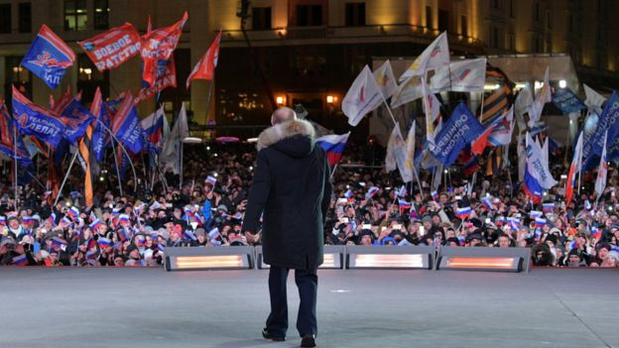Image copyright Image caption. victory was all but confirmed
"We have analyzed and monitored everything we could, everything that has arrived. Thank goodness, it's all rather modest so far," she told a commission meeting while speaking about violations.
She had earlier said that anyone involved in violations would be caught.
Sunday's vote was also the first in Crimea since Russia seized the region from Ukraine. Mr. Putin was scheduled to speak at a rally scheduled for the fourth anniversary of the annexation - the same day as the election.
The annexation was bitterly contested by Kiev and ratcheted up tensions between Russia and the West. Russians living in Ukraine were unable to take part in Sunday's vote because access to Russian diplomatic missions was blocked by the Kiev government.

